JOB DESCRIPTION
Finance & Data Analyst

- ROLE SPECIFICS
Job Title: | Finance & Data Analyst
Grade: | FMA3
Reports to: | Head of FP&A with dotted line to Head of Income
Location: | Birmingham / Hybrid (2 days on site per week) with occasional travel to London and Leeds
Department: | Finance
Vetting Requirement: | Basic disclosure

- About the role
What you’ll be doing | You’ll play a vital role in strengthening the Finance team’s capacity, with a primary focus on supporting the Head of FP&A and Head of Income across key areas of income, data analysis and forecasting, improving reporting and information practices as you go.  Your work will directly impact the accuracy, timeliness, and insight of financial reporting across the business.
Key Responsibilities | - Take an active role in the development, roll-out and evolution of new dashboards, reports and KPIs to the business as additional data sets are added to the Data Warehouse.  - Work with Management Accounts and the business to gain a deep understanding of variances and trends, and to identify resolutions where required.  - Support reviews with the business, providing context and commercial insight from the data to enable effective decision making.  - Contribute to the automation and improvement of financial reporting tools and processes to drive efficiency and insight.  - Prepare month-end income reports, including variance analysis, commentary, and KPI dashboards across multiple income streams.  - Support the Head of Income with the review and sign-off of income reports, coordinating inputs from income officers and supervisors.  - Deliver and maintain bi-monthly cash flow forecasts, including detailed trend analysis and breakdowns by student type and region.  - Monitor and analyse actual cash performance against forecasts, highlighting key variances and contributing to forecasting improvements.  - Take an active role in the development, roll-out and evolution of new dashboards, reports and KPIs to the business as additional data sets are added to the Data Warehouse.  - Work with Management Accounts and the business to gain a deep understanding of variances and trends, and to identify resolutions where required.  - Support reviews with the business, providing context and commercial insight from the data to enable effective decision making.  - Contribute to the automation and improvement of financial reporting tools and processes to drive efficiency and insight.  - Prepare month-end income reports, including variance analysis, commentary, and KPI dashboards across multiple income streams.  - Support the Head of Income with the review and sign-off of income reports, coordinating inputs from income officers and supervisors.  - Deliver and maintain bi-monthly cash flow forecasts, including detailed trend analysis and breakdowns by student type and region.  - Monitor and analyse actual cash performance against forecasts, highlighting key variances and contributing to forecasting improvements.  - Update and manage revenue provision models, incorporating partner mapping, flash rates, and key assumptions (e.g., WD, BD, YoS).
KPIs & SLAs | - Dashboards and KPIs issued on time. New reporting developed to agreed timeframes.  - Process Improvement & Automation: Contribute to the improvement or automation in reporting or analysis.  - Month-End Reporting: Complete and submit accurate income reports, variance analysis, and KPIs within 5 working days of month-end, with minimal corrections required.  - Cash Flow Forecasting: Deliver bi-monthly forecasts on schedule, with variance explanations and updated assumptions integrated into the model.  - Provision & Forecast Accuracy: Maintain up-to-date provision models and mapping tables with timely incorporation of key inputs (e.g. flash rates, withdrawal data).
Key Working Relationships | FP&A team, Income team  HE IT and Business Intelligence teams  Operational leads  External auditors

- About You
Your Competencies  1: Working Level  2: Advanced Level  3: Expert Level | Core  Results Driven – 2  Taking Ownership – 2  Collaboration – 2  Continuous Learning – 2  Role Specific  Analytical Thinking – 2  Attention to Detail – 2
Your Experience | Essential  Experience working in a finance role with exposure to financial analysis  Proven ability to meet tight deadlines and manage multiple priorities, especially around month-end and forecasting cycles.  Experience producing financial reports with clear commentary and variance analysis.  Excellent attention to detail, with a proactive approach to identifying and resolving discrepancies.  Strong communication skills, both written and verbal, with the ability to present financial information clearly to non-finance stakeholders.  Desirable  Experience working with income models, ideally in a student or B2C subscription-based environment.  Familiarity with forecasting models and reporting tools such as FluenceXL or Power BI.  Exposure to finance systems such as Microsoft Dynamics (F&O), Workday, or similar ERP tools.
Your Knowledge | Essential  Strong Excel skills (pivot tables, lookups, formula auditing, etc.) and confidence working with large data sets.  Solid understanding of financial reporting, including income recognition, variance analysis, and month-end close processes.  Familiarity with management accounting principles, including working capital, provisions, and cost analysis  Desirable  Understanding of data automation concepts and process improvement approaches in a finance setting.  Knowledge of revenue recognition and deferred income, particularly in a student or services-based environment.  Knowledge of cash flow forecasting principles and the ability to interpret trends and drivers.  Understanding of provision models (e.g., bad debt, withdrawal rates) and forecasting techniques
Your Qualifications | Essential  Part-qualified and actively studying towards a recognised professional accounting qualification (e.g. ACCA, CIMA, ACA).  Desirable  Qualified accountant. Continued professional development in data analysis, financial modelling, or systems/tools (e.g., Excel advanced courses, Power BI training).
What you’ll bring to QAHE | The successful candidate will be:  Self-motivated, independent, dynamic and results-driven.  Passionate about providing support to the business, with drive and enthusiasm to use management reporting to identify and deliver financial/operational improvement.  Adaptable, able to juggle multiple priorities and meet tight deadlines while maintaining high quality work  Impactful, resourceful, persistent and determined – with a sense of humour!

- WORKING AT QA HIGHER EDUCATION
QAHE is a private UK higher education provider working in partnership with UK universities to recruit to and deliver a range of programmes from foundation level to undergraduate and postgraduate degrees. We currently teach over 17,000 students from all over the world.
We work with our partner universities cover course subject areas including Accountancy, Business, Computing, Cyber, Digital Marketing, Events Management, Project Management and Web Development all delivered in city centre locations.
We believe everyone should be given access to outstanding higher education and our aim is to make that possible.
QAHE is committed to safeguarding and promoting the welfare of children, young people and adults with care and support needs. We hold the expectation that all staff share this commitment in creating a safe and inclusive environment and as an organisation, we comply with relevant legislation and best practices in safeguarding.

Please do not delete below this line until this document is complete.

Heading 1

Heading 2

Heading 3

Heading 4
Normal
- Bullet level 1
- Bullet level 2
- Number list
  - Letter list
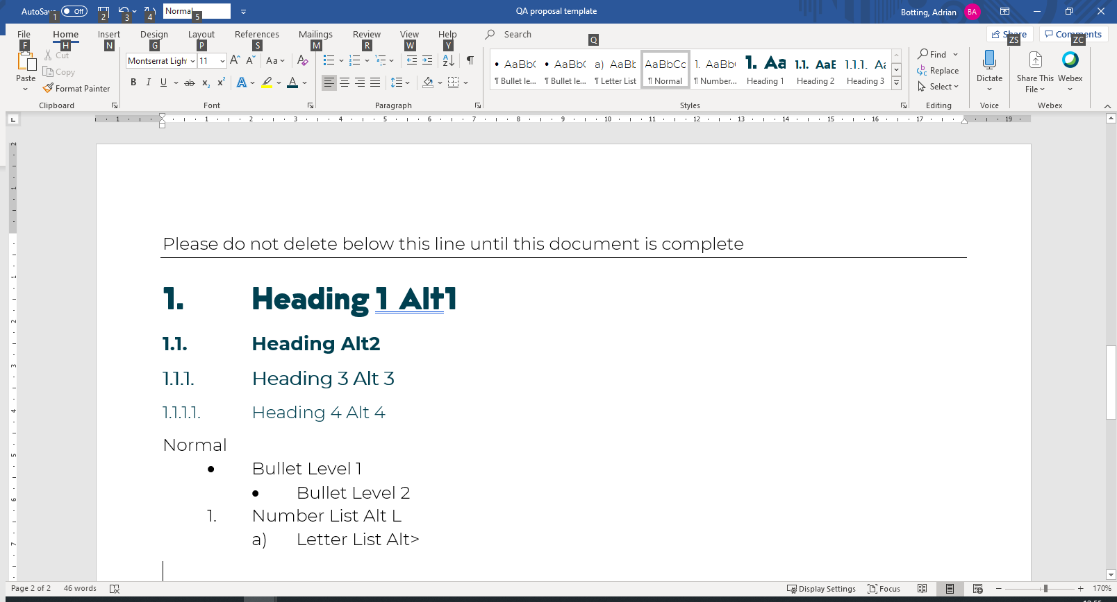
Figure 1 - captions should always be descriptive and engaging

Table 1 - Table captions always go above the table
Table Heading
Table
- Table bullet



