JOB DESCRIPTION
Social Media Executive and Content Creator

- ROLE SPECIFICS
Job Title: | Social Media Executive and Content Creator
Grade: | MDG2
Reports to: | Head of Marketing Services & Brand
Location: | London, Hybrid
Department: | Marketing – Higher Education
Vetting Requirement: | Enhanced Disclosure

- About the role
What you’ll be doing | If you’re a creative, passionate, driven social media enthusiast with a love for creating social first photos and videos, then this role is for you!  A Social Media Executive and Content Creator at QA Higher Education will play a crucial role in enhancing our online social media presence with a blended role of administrative and creative duties.  You’ll be working in the social media team which is fast paced, driven, enthusiastic but full of fun and creativity.  In this position you’ll be expected to undertake aspects of the administrative side of social media such as scheduling content and analytical reviews with the added flare of content creation.  From reviewing content and responding to comments, to taking social first photos and videos on campus, this role is the perfect mix of creative and administrative.  Your role will be fundamental in highlighting student stories, course offerings, provisions and business successes of both QA Higher Education and our partners. Growing our brand awareness and community across a wide variety of social platforms.
Key Responsibilities | - Liaise closely with the wider marketing team and business to curate social content to achieve marketing and business goals.  - Head to a campus location frequently to collate content. This will include you taking photos and videos and editing them in a social first manner to thrive on our social platforms.  - Creating and posting fresh, engaging content for all channels, ensuring we are constantly being proactive and industry leading  - Actively working closely with the Social Media Manager for the management and continued improvement of our social channels.  - Ensure our posts adhere to our/our partners’ brand tones of voice and brand guidelines.  - Day to day organisation of editorial calendars and scheduling with relevant platform  - Interact positively with followers and assist with customer service-related queries in a friendly and speedy manner.  - Feed online customer reviews through to the wider team.  - Support research efforts and monitor our partners and competitors on social media with social listening.  - Work alongside the Social Media Manager to analyse performance and engagement metrics, respond by adjusting the strategy to achieve better results and providing recommendations.  - Keep an eye on social media best practices, platform developments and industry trends.  - Support with ad-hoc social media-related queries.  - Support the development of our social media strategy and guidelines through research, benchmarking and audience identification.
KPIs & SLAs | The role holder will have regular reviews with key agreed objectives.  Key requirements will relate to delivering content through our social channels that aligns with our business objectives and community management response times
Key Working Relationships | - Social Media Executive  - Marketing Services & Brand Team  - Student Recruitment Marketing Team  - Wider QA Higher Education Marketing Teams  - Student Operation Teams  - Academic Teams  - Partner Marketing Teams  - Wider QA Higher Education Teams  - Third-party marketing agencies

- About You
Your Competencies  1: Working Level  2: Advanced Level  3: Expert Level | Core  Results Driven - 1  Taking Ownership - 1  Collaboration - 1  Continuous Learning – 1  Role Specific  Attention to Detail – 1
Your Experience | - You have 2+ years’ experience in a social media executive and content creation role, in either a B2B or B2C space. This includes use of Facebook, Instagram, LinkedIn and YouTube.  - Experienced in using Social Media scheduling and analytic tools  - You have some experience in dealing with customer queries and reviews online.  - Previous experience of understanding and reviewing data  - Have used a form of video editing and photo editing software, such as Adobe creative cloud, photoshop, premier pro, Capcut desktop, Canva, etc.  - Experience of Google Analytics 4 would be advantageous
Your Knowledge | - You’re a confident admin on LinkedIn, Facebook, Instagram, Twitter and YouTube accounts, and familiar with Facebook and LinkedIn’s ad platforms.  - You have demonstrable knowledge of social media analytics and best practice KPIs.  - You will be familiar with social media and CRM tools like Hootsuite, Later, Planoly, Sprout Social and Orlo.  - You’re familiar with and know how to ideate, shoot and edit basic social first videos or one-shots.
Your Qualifications | - Educated to degree level/level 6 within a Marketing or English subject related field or alternatively a background in the marketing field / professional qualification would be advantageous.
What you’ll bring to QAHE | - You’ll bring a passion for the education or digital sector, and great organisational, writing and people skills!  - Should have a proactive and driven approach to work  - A willingness to learn and support the team  - A desire to deliver high quality work and constantly looking to improve outputs  - Would suit an ambitious individual with a desire to either progress with more responsibility or to expand upon their creative skillset.  - A positive outlook with a ‘can do’ attitude  - Passionate about marketing  - Innovative, inquisitive and imaginative  - A diligent individual

- WORKING AT QA HIGHER EDUCATION
QAHE is a private UK higher education provider working in partnership with UK universities to recruit to and deliver a range of programmes from foundation level to undergraduate and postgraduate degrees. We currently teach over 17,000 students from all over the world.
We work with our partner universities cover course subject areas including Accountancy, Business, Computing, Cyber, Digital Marketing, Events Management, Project Management and Web Development all delivered in city centre locations.
We believe everyone should be given access to outstanding higher education and our aim is to make that possible.
QAHE is committed to safeguarding and promoting the welfare of children, young people and adults with care and support needs. We hold the expectation that all staff share this commitment in creating a safe and inclusive environment and as an organisation, we comply with relevant legislation and best practices in safeguarding.

Please do not delete below this line until this document is complete.

Heading 1

Heading 2

Heading 3

Heading 4
Normal
- Bullet level 1
- Bullet level 2
- Number list
  - Letter list
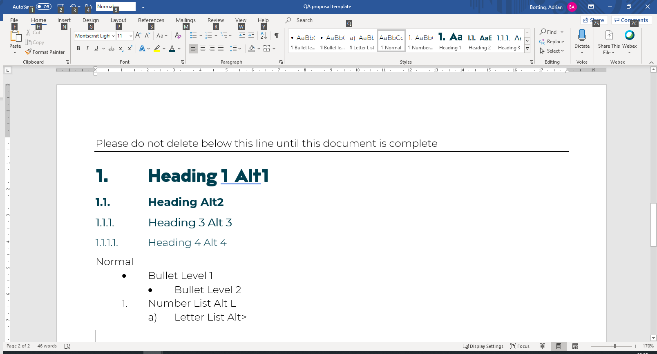
Figure 1 - captions should always be descriptive and engaging

Table 1 - Table captions always go above the table
Table Heading
Table
- Table bullet



