JOB DESCRIPTION
Librarian

- ROLE SPECIFICS
Job Title: | Librarian
Grade: | 5
Reports to: | Head of Library Services
Location: | London
Department: | Library
Vetting Requirement: | Basic disclosure

- About the role
What you’ll be doing | You will be acting as a campus and learning & teaching librarian, and a partnership liaison. You will be delivering library services and information literacy instruction, provide support to students and academic staff, and the wider QAHE community. This is a multifaceted role which is likely to continuously evolve to reflect the campus and library services development.
Key Responsibilities | - Supporting library users at all levels in making best use of collections and services for increasing their attainment; anticipating and resolving enquiries and creating appropriate guidance materials in various formats.  - Providing library liaison to one or more QAHE academic partnerships. This includes maintaining collaborative working relationships with partner university librarians and QAHE academics and programme managers; ensuring the QAHE Library provision meets the needs of the students on relevant programmes.  - Managing campus collection development.  - Identifying the needs and opportunities for information literacy training across the campus and partnership provision, and other QAHE programmes as required; preparing and delivering inductions and information literacy sessions, online and face to face as required; delivering group and one-to-one support sessions; analysing, manipulating and interpreting data, to produce reports, such as analysis of workshop feedback.  - Promoting copyright compliance and ethically responsible use of information.  - Building and maintaining strong working relationships with contacts in other departments or external bodies including participating in networks/working groups to coordinate activity.  - Occasionally working at other campuses and sites in London, Birmingham, and Manchester; and outside the contracted hours as required by the needs of the service.  - Any other reasonable duties that fall within the scope of the post as allocated by the line manager following consultation with the post holder.
KPIs & SLAs | - Student and staff satisfaction  - Visibility in the academic process  - Resources and services use and evaluative feedback  - Library session participation and feedback
Key Working Relationships | - Librarians and Head of Library Services  - Academic programme managers and lecturers  - Academic Community of Excellence

- About You
Your Competencies  1: Working Level  2: Advanced Level  3: Expert Level | Taking ownership (1)  Continuous learning (2)  Instructional delivery (2)  Compassionate librarianship (2)
Your Experience | Relevant experience of working in a library/information environment; and/or relevant teaching experience.
Your Knowledge | - Awareness of and keen interest in the HE environment and relevant pedagogies.  - Awareness of relevant technologies: LMS, ebook libraries, research databases, generic and specialist search engines, VLEs; web and video document production, AI.  - Literature searching and reference management.  - Library collection management in print and electronic environments.
Your Qualifications | - Degree level or above; if not already achieved – willingness to undertake postgraduate library-related study.
What you’ll bring to QAHE | - Passion for making students’ experience meaningful and rewarding.  - Commitment to professional development in the areas of information management, pedagogy, information and digital literacy, and other related disciplines.  - Ability to develop effective relationships with colleagues across teams and departments.  - Willingness to undertake a DBS check prior to formal start date being confirmed.

- WORKING AT QA HIGHER EDUCATION
QAHE is a private UK higher education provider working in partnership with UK universities to recruit to and deliver a range of programmes from foundation level to undergraduate and postgraduate degrees. We currently teach over 17,000 students from all over the world.
We work with our partner universities cover course subject areas including Accountancy, Business, Computing, Cyber, Digital Marketing, Events Management, Project Management and Web Development all delivered in city centre locations.
We believe everyone should be given access to outstanding higher education and our aim is to make that possible.
QAHE is committed to safeguarding and promoting the welfare of children, young people and adults with care and support needs. We hold the expectation that all staff share this commitment in creating a safe and inclusive environment and as an organisation, we comply with relevant legislation and best practices in safeguarding.

Please do not delete below this line until this document is complete.

Heading 1

Heading 2

Heading 3

Heading 4
Normal
- Bullet level 1
- Bullet level 2
- Number list
  - Letter list
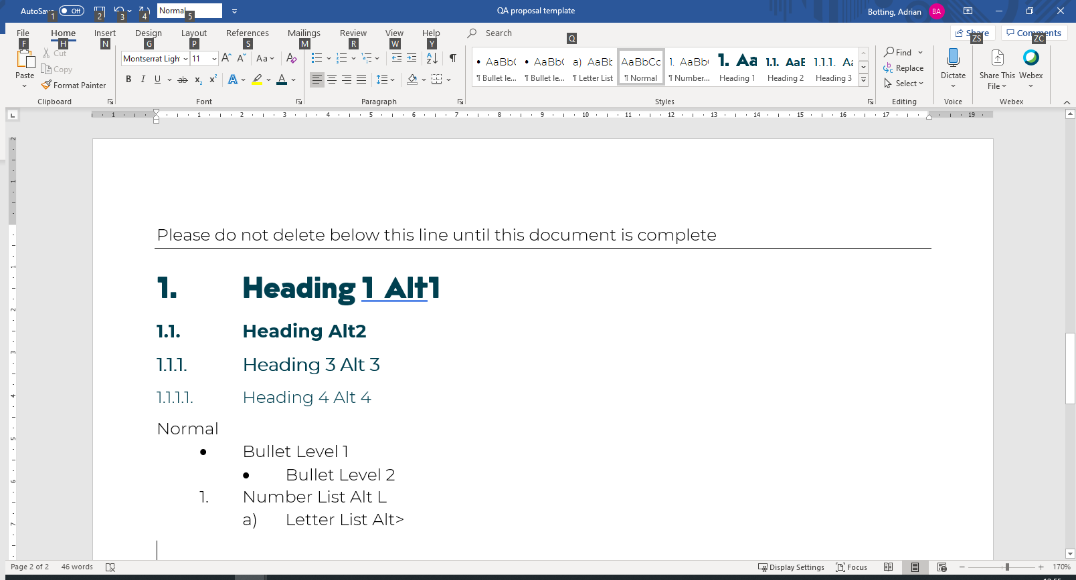
Figure 1 - captions should always be descriptive and engaging

Table 1 - Table captions always go above the table
Table Heading
Table
- Table bullet



